Chonbuk National University

The Feeling Korea 2016

The Feeling Korea program guide book

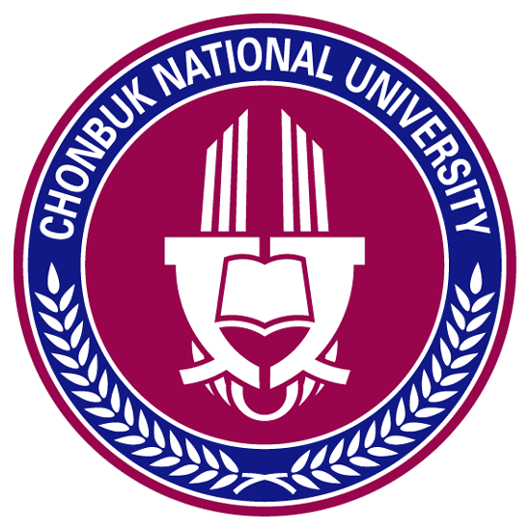

Office of International Cooperation

Baekjedaero 567, Jeonju, Jeonbuk
54896 South Korea
Tel: +82-63-270-2248
Fax: +82-63-270-2209

1. The Feeling Korea Program

A. Introduction
The Feeling Korea program that has lasted since 2002, was initiated by the thoughts of how to let foreigners learn about Korean culture in an interesting and amusing way. International students who will be visiting our university for their vacation will experience various types of Korean culture through Korean language classes, Korean cultural experience program, cultural exchange between university students, experiencing traditional Korean culture and Korean popular culture that led to the so called Korean Wave.

B. Schedule
- 1st: 2016. 7. 18(Mon) ~ 7. 29(Fri)
- 2nd: 2016. 8. 1(Mon) ~ 8.12(Fri)
DATE |  | Morning | Afternoon
1st  week | Sun | Dormitory Check-in
 | Mon | Welcoming Ceremony & Orientation | Campus Dule-trail tour
 | Tue | Korean classes | Making pottery
 | Wed | Korean classes | Traditional Music  (Imsil Philbong village)
 | Thu | Korean classes | Making traditional Fan
 | Fri | Korean classes | Field TripⅠ (Buan city)
 | Sat | Field TripⅠ(Buan city)
 | Sun | Free Time
2nd  week | Mon | Korean classes | Traditional Wedding
 | Tue | Korean classes | Taekwondo
 | Wed | Korean classes | Making Traditional Food
 | Thu | Field Trip Ⅱ  (Amusement park & Seoul)
 | Fri
 | Sat | Go to Airport

- The program in the schedule is subject to change.
- Field Trip is Optional

Photo of program
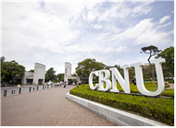  Campus Tour | 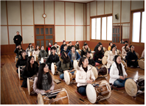  Traditional Music | 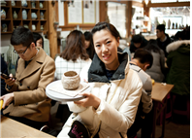  Pottery Experience
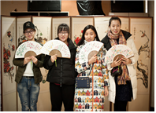  Making Fan Experience | Beach Experience | 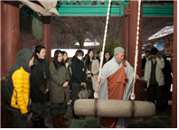  Temple Stay
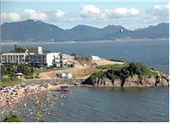  Swimming in Mohang | 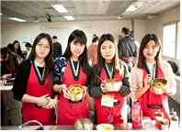  Bibimbap Experience | 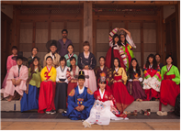  Traditional Wedding
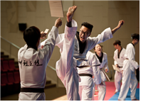  Taekwondo in Muju  (Taekwondo Experience) | 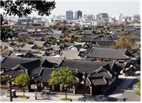  Hanok Village in Jeonju | Everland
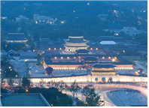  Seoul(Gyeongbokgung) | 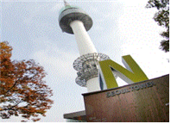  Seoul (Namsan N-Tower) | 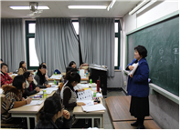  Korean Language Class

C. Fee
- Original Fee: $ 600
- Scholarship for the partner university: $ 500
- The fee must be prepaid when applying for the program and the receipt must be submitted with the application documents. Any commission occurred when depositing the tuition fee must be covered by the students.
- This fee Includes tuition, dormitory, meal fee but excludes flight and transportation fee.

Bank Account
Bank Name: THE JEONBUK BANK, LTD. SEOUL, KOREA
Swift Code : JEONKRSE
Branch Code : 529
Beneficiary’s Name: CHONBUK NATIONAL UNIVERSITY INTERNATIONAL AFFAIR OFFICE
Bank Address : 2F, Seoul Finance Center, 84 Taepyungro 1-ga, chong-gu, Seoul, Korea
Bene’s A/C No. : 529-83-0316715
※ On a bank form, please select “OUR”, instead of BNE, under the section, Details of Charges. The final amount for a student wired to our bank account must be equal to tuition fee

Return Policy
Refund available if cancelled before the starting date of program.
Pick-up & Drop-off fee is not refunded.
Any Commission occurred related to cancellation will be deducted from the refund.

2. Flight

A. Booking
For a smooth procedure, please book the flight that arrives in Korea in the morning and that departs from Korea in the afternoon. If you have your own individual travel plan, please plan it after the completion of program.

B. Pick-up
If you already apply pick-up service, We will offer pick-up service from Inchen Airport.
After book the flight tickets, Please let us know flight Schedule. Our Volunteer who lifts the flag will be waiting students at Arrival Gates. If you cannot find volunteer helpers while exiting, please come to the seating rows next to Incheon Airport Arrival Gate 12. Volunteer will guide students to pick-up Bus. After all of students arrive at Incheon Airport, we will start to Chonbuk National University. An estimate travel time from the airport to the campus is about 4 hours by bus.

Please refer to the pick-up schedule below. If you cannot manage to arrive in the arranged time, then we cannot offer pick-up service. It usually takes 60~90 minutes to exit the airport after the plane lands. So please book the flight considering the exiting time.

<Pick-up Schedule>
Date | Time
7.17(Sun) / 7.31(Sun) | 12pm ~ 4pm

C. Airbus Remousine
If students miss the pick-up Bus, We highly recommend students take the airport limousine bus service to Jeonju which runs from both Incheon and Gimpo. Information on which bus to take and how to purchase tickets is available at the airport information desk in several languages, including English. The limousine bus service to Jeonju departs from Exit 9C and costs approximately 31,000 won and will take you to the Jeonju Core hotel.

Map of Limousine Bus Stop at Incheon Airport
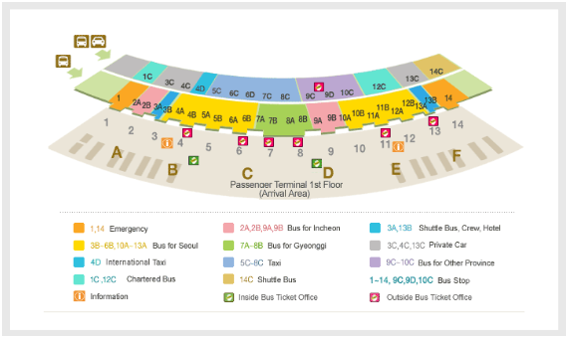
After arriving in Jeonju, you can take taxi to get to Residence Hall of Chonbuk National University. It will cost less than 10,000 won. If you need to communicate with the taxi driver you may show him/her the following message to request Chonbuk University as your destination.

“전북대학교로 가고 싶어요. 전북대학교 기숙사로 가주세요”

3. Campus Life
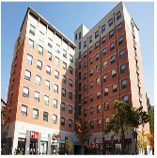
A. Housing
All students will stay at Cham-bit Residence Hall during the program.
Cham-bit has an enforced curfew policy; students are expected to have returned to the dormitory before 11:50pm. Students will be issued with an electronic key on arrival which will allow them access to the residence hall. A student using the key to access the building between 11:50pm and 4am will receive a mark against their name, in addition to the marks given for misuse of the dormitory access key, random roll calls will be performed after 11:50pm and students not present for roll call will receive extra marks. Excessive marks will result in that student’s dormitory privileges being revoked, that student would then be expected to find other accommodation. And in the room you must take off shoes.
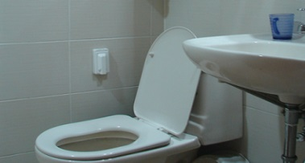
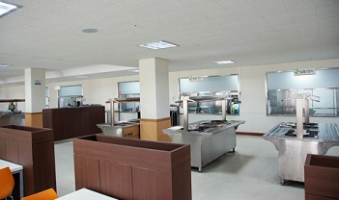
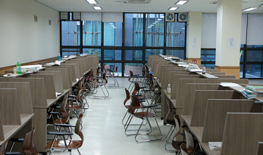
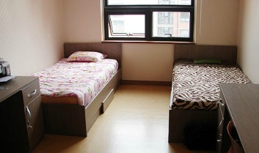
Instructions
Students are responsible for the care of rooms and equipment. The University provides no cleaning service in student dormitory rooms. Charges will be made for damages to, unauthorized use of, or alterations to rooms, equipment or buildings and for special cleaning necessitated by improper care of rooms.

Meals
Meals will be provided in the cafeteria beneath the 2nd Cham-bit building for students displaying an electronic access key.

Mealtimes
 | Days
 | Mon ~ Fri | Sat | Sun
Breakfast | 7:30am ~ 9:00am
Lunch | 12:00am ~ 1:30pm
Dinner | 5:30pm~7:00pm | 5:30pm~6:30pm | 5:30pm~7:00pm

Furniture
Desk, chair, closet, bed, air conditioner and toilet

WIFI
Wifi is not available inside the dormitory so please bring your own router if you want to use the internet. In case of laptop, if you bring the LAN line, you can use the internet immediately.

Personal Items required when moving in
Toiletries, transformer (Korea use 220V), a pair of slippers (you must not enter the corridor with bathroom shoes), personal goods. Please also bring the pillow and duvet sets as well. The dormitory room does not have a phone, so if in need of a phone, please bring or purchase your own.

 | Time
 | Mon ~ Fri | Sat | Sun
Hot water | 6:30am ~ 9:30am, 9:00pm ~ 12:00am
Air conditioning | Each room has its own air conditioning system;  students are able to control the electric boiler

Curfew and Sleep-out
- Students must return to the residence hall by 23:50.
- The sleep-out form at the assistant's office must be filled out before 23:00 on that day. If students want to stay out for more than 5 days, they must fill out the application form and submit it to the deputy director and get permission for it. If not, the students will be penalized.
- Regular roll call can occur more than twice a week by the assistant or the manager of each floor. Special roll calls can occur by the director or head of the administration office, if necessary.
- Roll call is done randomly after 23:50 and all residents must take part in order to avoid penalty points. However, they may receive exemption if they have prior consent.

B. CBNU Facilities
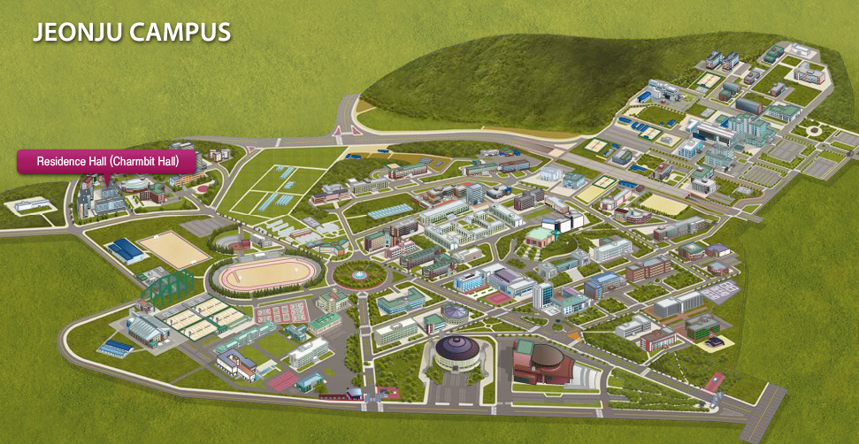
Libraries
Chonbuk National University has two main libraries; The Central Library, Which holds more than one million books and four thousand titles of scientific journals, and the Annex to the Central Library. In addition there are also specialized libraries such as Learning Library, Law School Library, Medical Library, and Dentistry Library.

Other Facilities
Chonbuk National University has many facilities available to students; there are various shops, cafes, restaurants and vending machines located around campus as well as a bookstore and post office. An ATM which accepts foreign bank cards is located just off the campus; across the street from the Lotteria fast food restaurant, which is outside of the old gate. Shinhan Bank in Gaeksa (about 10 minutes by bus) also has an ATM that accepts foreign bank cards.

4. Contact Us

The Office of International Cooperation is located on the 2nd floor of No. 1-10 Building

We are always here to help you.

Office Hours 9:00am ~ 6:00pm (lunch 12:00pm~1:00pm)
Title | Name | Tel | Email
Coordinator | Seulki Park | 82-63-270-2248 | Feelingkorea@chonbuk.ac.kr

